Bella Scholtes, Victoria Smith, Faleh Alzoubi, Mohammad Abdallah

ENGR 1182

Dr. Meagan Ida- 8:00AM

5 November 2021

A-16 : Prototype Requirements & Verification Plan

**Prototype Design Requirements**

|  |  |  |
| --- | --- | --- |
| **Design Requirement** | **Threshold** | **Goal** |
| Effective energy conservation | 1200W-1800W | 1400W-1500W |
| Time to dismantle for transportation and storage | 15 to 30 minutes | <20 minutes |
| Weight bearing | >250 lbs | 350 lbs |
| Operating lifetime | >5 years | 7 years |
| Noise Canceling Capabilities | 50 to 130 decibels | >110 decibels |
| Size | 6x6in - 9x9in | >8x8in |

Energy conservation determines the amount of voltage we would design the outlet to be able to handle.

The time to dismantle is for the convenience of the user and the design of our pod would allow the user to be able to dismantle and transport the object in less than 20 minutes. This means that the way we design our product needs to be able to dismantle and fold for transport.

Weight bearing and noise canceling capabilities will effect what material we choose to use for our design. The material we use must be sturdy/strong in order to handle the weight capacity but also it needs to have noise canceling capabilities. An option for this material would be a soundproof foam material that will keep noise out of the pod and be lightweight enough to transport easily.

The operating lifetime will be fulfilled using lasting materials and a well-made design that has minimal wearing capabilities.

The size of the design in Solidworks is going to be 8x8 inches.

**Testing Methodology/Verification Plan**

We will verify the weight capacity and auditory dampening of the model through two Solidworks test. The first test will use a structural analysis test to determine how much weight the structure can hold. We will first test that it can hold 150 lbs and then test that it can hold 350 lbs. The goal is for it to pass both tests.

The second test that we will do in Solidworks will assess how much sound the structure can dampen. We will use the flow simulation noise prediction test to analyze this. We will important a part that makes a lot of noise into our Solidworks file with our Zoom Room. The Solidworks test will show us how quiet the surroundings of the part that is making the noise are. This will allow us to test how much noise our Zoom Room is dampening. We will find a part that makes 60 dB and 100 dB, and then see how loud the noise is inside the Zoom Room. The goal is for it to be no louder than 40 dB in both tests.

**Correlation Matrix & Scorecard**

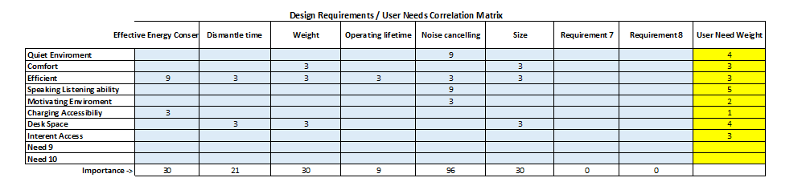

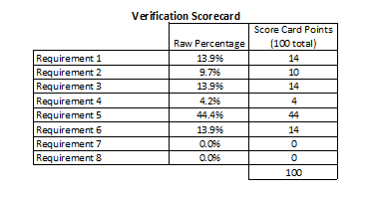

A correlation matrix was used to determine how certain design requirements are related to the user’s needs. The higher weighted requirements will be favored in the final design as well as in considering potential design tradeoffs. Based on the results of the design requirements matrix, the most important requirements that will be favored will be noise cancellation, weight/size requirements, and energy efficiency. Noise cancellation scored the highest meaning it will be a top priority in our design. The weight and size requirements also scored high due to the nature of the design being mobile and needing to be adequately sized. Finally, being energy efficient will be the third requirement we will direct the design toward; however, it will be less important than the other requirements discussed above.

**Prototype Detail Design**

Due to the limitations of being all online, we decided that we could best work as a team on a Solidworks part. This would give the clearest view to all members of what the prototype was looking like. The limited experience of team members with manufacturing also indicated that this would be the best option. Additionally, using Solidworks will allow us to more accurately test the weight capacity and acoustic dampening of our model. It would be difficult to test both of these aspects in a physical model. We used Solidworks to model the sketch as a 3-D parts assembly. The following is the original sketch:

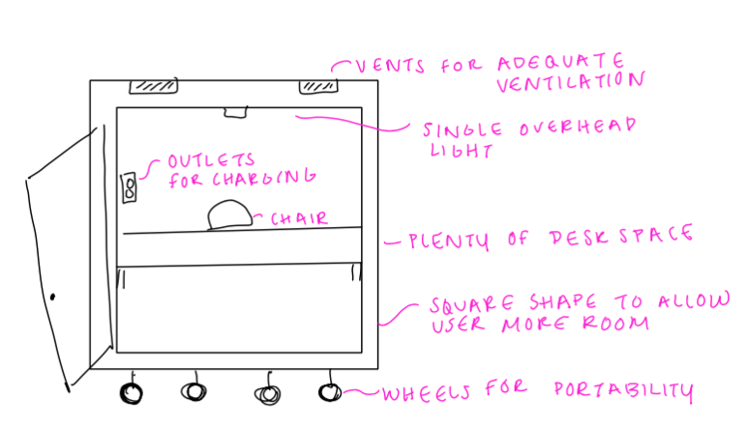

The following picture shows the isometric view of our Solidworks assembly. We made sure to add important features such as air vents, the desk, and the wheels. Additional features from the sketch can be seen upon further inspection, such as an outlet for charging and a chair. Modelling and testing our product in Solidworks is the final stage of prototyping that we will achieve. This protype can be used to showcase our design and gauge target audience interest.

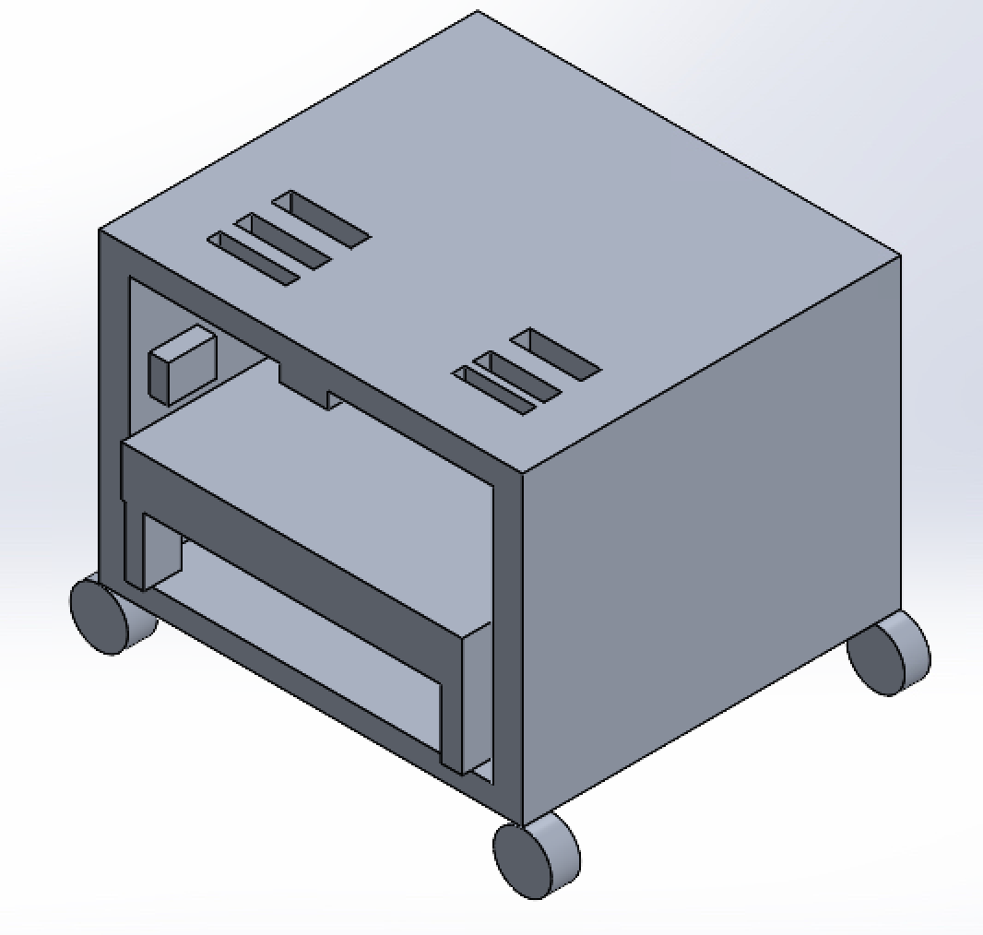

Team Member Assignments

|  |  |  |  |
| --- | --- | --- | --- |
| Project Manager for Assignment | | | |
| Bella Scholtes | | | |
| Deputy Manager for Assignment | | | |
| Faleh Alzoubi | | | |
| Drafted Assignment | Reviewed Assignment | Revised Assignment | Proofread Assignment |
| Faleh Alzoubi | Victoria Smith | Mohammed Abdallah | Victoria/Mohammed |
| Other Contributions | | | |
| Note taking for brainstorming: Group  Scheduling: Bella/Victoria  Document creation logistics: Faleh Alzoubi | | | |
| Problems Overcome | | | |
| * Coming up with a problem to solve * Identifying what exactly were the tasks that the user would experience with going to zoom classes * Coordinating so that the assignment was submitted on time * Finding best dimensions | | | |